**EDS Webinar**

**05 December 2024, 16:00 – 17:30 CET**

**NewSkin OITB webinar: Nano-enabled Membranes for Brine Mining and Desalination**

**Summary:**   
  
Open Innovation Test Beds (OITBs) are coordinated efforts supported by the EU that aim to accelerate the uptake of advanced technologies. NewSkin OITB (H2020 GA 862100) main objective is the transfer of advanced surfaces and structures to the market.

During the last 4 years of execution NewSkin has worked in engaging main advances in nano-enabled membranes developers as well is the validation of a set of technologies to upscale nano-enabled membranes.

Nano-enabled membranes open the path to new levels of performance in terms of fouling, selectivity and efficiency. The webinar will introduce 5 nano-enabled membranes concepts as well as the role of Open Innovation Test Beds to bring into reach of the ecosystem the necessary resources for accelerated uptake.

**Main target(s):**

Membranes developers, manufacturers and operators.

**PROGRAM**

* Rohit Karnik (MIT, NewSkin Ecosystem), "Scalable mono-atomic graphene membranes."
* Carien Spagnolo (NEMATIQ, NewSkin Service User), "Highly efficient Graphene oxide membrane technology."
* Noemi Fiaschini (Nanofaber, NewSkin Partner) “Electrospun coated membranes to tailor membranes salt rejection and selectivity, and antibacterial membranes treated with HiPIMS”.
* [Simon Isaksson](https://www.linkedin.com/in/simon-isaksson-5677525a/) (Retein, NewSkin Service User) "Novel technology for precise and sustainable recovery of valuable resources from water."
* Albert Schnieders (CNM Technologies GmbH, NewSkin Service User). "Molecular-thin Carbon Nanomembranes."
* Carlos del Castillo (NewSkin AISBL, NewSkin Partner) "Open Innovation Test Beds Services for Membranes production and modification: Facilities and examples."

**SPEAKER INFORMATION**

**Rohit Karnik** (Massachusetts Institute of Technology, NewSkin Ecosystem)



**Bio**

Rohit Karnik is a professor in the Department of Mechanical Engineering at MIT where he leads the Microfluidics and Nanofluidics Research Group. His research focuses on the physics of micro- and nanofluidic flows and the design of micro- and nanofluidic systems for applications in water, healthcare, energy, and the environment.

**Carien Spagnolo**, (NEMATIQ, NewSkin Service User)

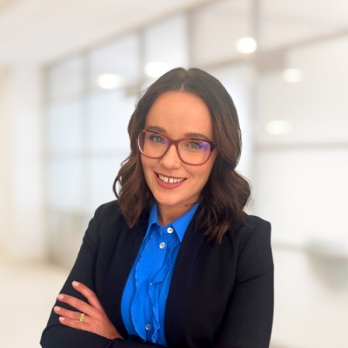

**Bio**

Carien Spagnolo is an experienced chemical engineer with a passion for entrepreneurship and global business development. Her passion for business compelled her to pursue an MBA at the University of the Witwatersrand in 2018. She graduated with distinction in July 2020, and is passionate about making a difference in the environmental sector.

**Noemi Fiaschini** (Nanofaber, NewSkin Partner)



**Bio**

Noemi Fiaschini is a Project manager & Bio-Validation Expert in Nanofaber srl. Noemi Fiaschini received her PhD in the University of Rome and has a strong background in electrospun materials, biobased and nano-materials development.

[**Simon Isaksson**](https://www.linkedin.com/in/simon-isaksson-5677525a/)(Rettein, NewSkin Service User)

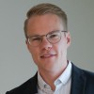

**Bio**

Co-founder & CEO of Retein AB. [Simon Isaksson](https://www.linkedin.com/in/simon-isaksson-5677525a/) received his PhD at Chalmers Department of Chemistry and Chemical Engineering in 2019, he and his research leader at the time Martin Andersson, decided to take their results in biotech further - forming a startup called [Retein](https://www.linkedin.com/company/reteintech/). A company that develops water filters that uses nature’s finest water purification to provide a new, unique way to produce clean water energy-efficiently, while recovering additional resources. Since then, the technology’s unique way of purifying water has attracted interest.

**Dr. Albert Schnieders** (CNM Gmbh, NewSkin Service User)



**Bio**

Dr. Albert Schnieders is CEO of CNM Technologies GmbH. Before founding CNM Technologies together with two partners in 2011, Dr. Schnieders worked in the USA as general manager of Tascon USA, a contract laboratory specialising in chemical surface analysis, and as application scientist at IONTOF-USA, the US-subsidiary of IONTOF, a manufacturer of surface analytical equipment. Dr. Schnieders earned his degree in experimental physics in 1999 at the University of Münster, Germany.

**Carlos del Castillo** (NewSkin AISBL)

**Bio**

Carlos del Castillo is a Chemical Engineer and MSc in Sustainability and Project Management. With 20 years of experience in Innovation Projects management and execution, he plays the role of Project Manager in the [ECCS (European Convention for Constructional Steelwork)](https://platform.newskin-oitb.eu/entities/15-eccs-european-convention-for-constructional-steelwork) and NewSkin AIBSL. He is the [NewSkin Open Innovation Test Bed](https://platform.newskin-oitb.eu) Project Manager, responsible for the project follow-up and the coordination of partners interactions, technical and route to market activities.

This project has received funding from the European Union’s **Horizon 2020** research and innovation programme under grant agreement No 862100 (**NewSkin**). The output reflects the views only of the author(s), and the European Commission cannot be held responsible for any use which may be made of the information contained therein.